**Gucci vs. Guess Copyright Infringement Case Study (2009)**

In 2009, Gucci sued Guess for reportedly stealing several of its recognisable designs, including the GG monogram, diamond pattern, and interlocking Gs. Guess was charged with trademark infringement, unfair business practices, and counterfeiting in the case. The trial for the lawsuit took place in 2012, and Gucci won.

**BACKGROUND**

**PLAINTIFF:** Gucci is an upscale clothing company that was established in Florence, Italy, in 1921. The company is renowned for its high-end goods, which include apparel, accessories, and leather goods. Gucci has been effective in establishing a strong brand identity through its distinctive designs, logos, and trademarks, which have come to be associated with exclusivity and luxury.

**DEFENDANT:** American clothing company Guess was established in 1981. The company, which competes with Gucci in terms of target market, is well known for its casual apparel and accoutrements. Additionally, Guess incorporates logos and trademarks into its goods, such as the triangle logo, which is well-known to customers.

**THE CASE:** In 2009, Gucci sued Guess, alleging that the company had copied its designs and trademarks. Gucci asserted that Guess copied its designs, including the GG monogram, diamond pattern, and intertwined Gs. Additionally, Gucci claimed that Guess had stolen its branding, packing, and advertising techniques.

Gucci claimed that Guess had deliberately copied its designs in order to profit from Gucci's notoriety and brand image. Gucci asserted that Guess had gone so far as to use the same suppliers and facilities as Gucci to make its goods.

Guess disputed the accusations and insisted that its designs were unique and unrelated to those of Gucci. Guess asserted that its trademarks and logos were original creations that it had not meant to imitate Gucci's designs.

The verdict was in Gucci's favour after the matter went to trial in 2012. The court determined that Guess had participated in unfair competition and counterfeiting as well as actual copying of Gucci's trademarks and designs. Guess must pay Gucci $4.7 million in damages, the court ruled.

The judge also ordered Guess to cease using the trademarks and designs that were being used infringingly and to destroy all of the unsold products that contained those designs. Additionally, the judge ruled that going forward, Guess must not use any trademarks or designs that are identical.

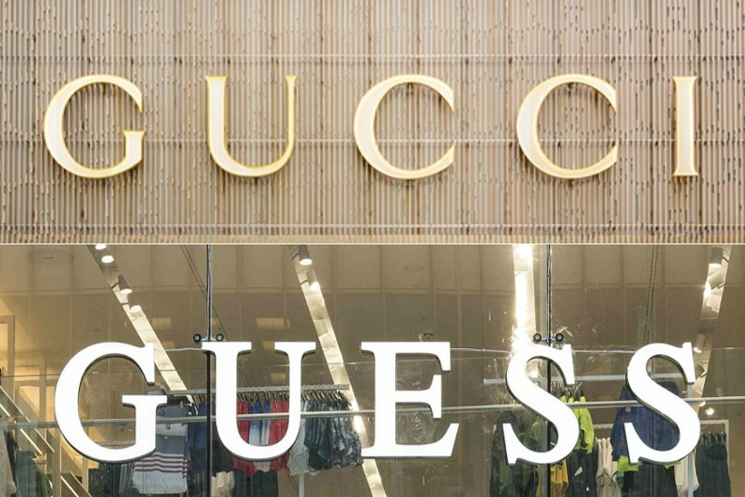

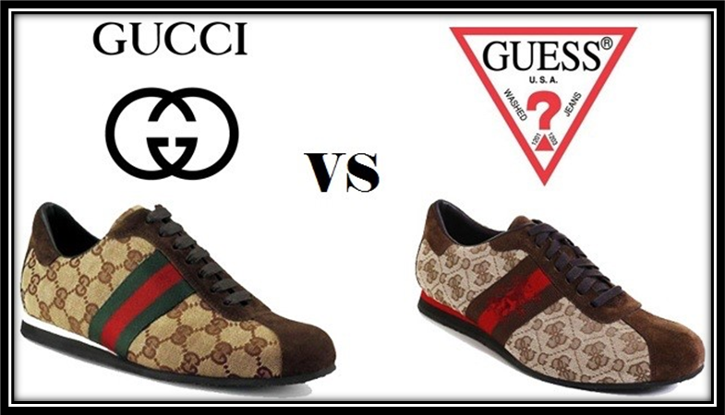

**CONCLUSION:**

The Gucci vs Guess copyright infringement case is an example of how brands can protect their intellectual property and trademarks from imitation and copying. Gucci's victory in the case shows that brands must be vigilant in protecting their designs and trademarks, and they must take legal action against any imitators or infringers. The case also highlights the importance of creativity and originality in the fashion industry, and how copying can harm the reputation and image of a brand.